Home is where the heart is. Literally

‘casa’, ‘domus', ‘oikos’, ‘maison’; upon meeting any of these words in various languages we may understand one of two things: either a physical shelter, be it temporary or permanent, private or public; or perhaps we may push the word harder and infer a richer, more abstract concept, that of ‘home’.
Indeed the intensity of the semantic laden in the word ‘home’ perhaps is due to its uniqueness among languages (at least until more recently) and we might wonder whether therefore the sensation, associations of the concept of home is more acute for for speakers where ‘house’ and ‘home’ have distinct meanings.

I will be looking at various concepts of home considering examples in art and literature while suggesting that the cliché ‘home is where the heart is’ may actually be taken quite literally, that home may indeed wherever our self: our body, mind and heart is.
Despite this distinction between what can be denoted by ‘house’ and ‘home’ respectively, when we look deeper into various conceptions of the latter, we find that after all perhaps even in the some abstract senses, they can become interchangeable without losing the depth of the meaning. For as we might surely say a snail carries its house on its back, we would happily also say it carries its home. This is because home is after all, for a large number of people, the physical dwelling which they inhabit and carries within it myriad objects, associations and feelings not necessarily considered on their own, out from under the roof. But consider a house robbed of all its possessions during a burglary, leaving just the mere walls and ceilings of the house. Can you consider this still a home?
Indeed again, many would say it is not the physical objects and items inside the house that makes it your home but the people you love, the family, and perhaps the pets with whom you live in the house. Therefore when changing properties people say ‘we’re moving house’, while implying the change of physical structure keeps intact their ‘home’. We might well say that the ‘home’ is ‘moving house’.
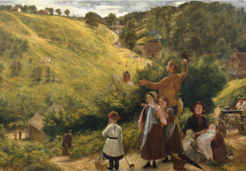
We can go one further and suggest that the requisites for a home, are not just the apparent personal possessions, decoration, nor even the people whom you share it with, but indeed, the land, location, street, country, and all the subtle associations that belong to these variables. Certain noises, and views from the window, customs of the country, and weather tendencies, can all contribute to a broader sense of home, seen when people refer to their country in nostalgic and patriotic ways.

Richard Redgrave, ‘The Emigrant’s Last Sight of Home” 1858
Image released under Creative Commons CC-BY-NC-ND (3.0 Unported)

Redgrave’s painting depicts a moment of parting for a family from their home and homeland in the post industrial revolution years when many British families moved abroad to colonies as a result of high unemployment. Its subject matter resonates with many situations of emigrants and immigrants all over the world today, but unlike the many war torn countries, overcrowded cities, and drought-ridden rural areas causing mass emigration today, the painting conveys the harmonious calm and beauty of the place this family are leaving behind. The ‘home’ referred to in the title is not focusing on a personal family house, but in fact the whole country, England’s ‘green and pleasant lands’ , and despite the apparent dismay on the family’s faces in the foreground corner, the vast majority of the painting is occupied by the idyllic countryside embraced in the centre by the man’s open arms, which effuses an affectionate sentimentality.

However, I would like to suggest that as that family packs up and travels to their new land to resettle, they will, in time, feel at home again, even as the parents may grow old and die or the children grow up and move away, each person has the potential to feel at home again despite being in completely different circumstances. For this reason, I argue that it is not a building, not items, not a country nor even people, which constitute our sense of home; I suggest that it is our bodies themselves.
I have travelled rather frequently in my recent life and lived in many places and yet whatever the place, I have somehow, with time managed to feel at home and create a new home. When at a stage in my life I experienced the incredible pain and disorientation of heartbreak, it seemed that I had associated all comforts and familial feelings of home to one person, which upon losing them could have left me permanently adrift. But in fact it had not just been that person who had travelled with me through many situations of both discomfort and joy as I had thought, it had been me myself, also.

“Your house is your larger body…Your house shall not be an anchor but a mast”
says Almustafa, the ‘prophet’ in Khalil Gibran’s much-loved work, as he suggests that if we stay firmly fixed in our houses, defending them and locking them up we are in fact denying our own ability to be free and experience ourselves and the worldly experiences we long for. We have mobile bodies, legs to roam the ‘ever-distant’ ‘grove or hill-top’, and yet we try to fix ourselves, and some material belongings in a fixed abode. If we instead conceptualise our ‘home’ to be our body itself, we cut loose the bonds inhibiting us and suddenly become free to experience and travel, all the while having the possibility of an innate sense of security within ourselves.

In contrast, we may look to an example of someone experiencing a sense of disconnection from their home, via a transformation in their body. Catullus 63, recounts the tale of Attis travelling far from his home to follow the cult of Cybele, through whose rituals he castrates himself in a frenzied madness. Upon regaining clarity of mind he reflects on his home:

“So after soft slumber, freed from violent madness,
as soon as Attis himself in his heart reviewed his own deed,
and saw with clear mind what lie had lost and where he was,
with surging mind again he sped back to the waves.
There, looking out upon the waste seas with streaming eyes,
thus did she piteously address her country with tearful voice:
" O my country that gavest me life! O my country that barest me!
leaving whom, all wretch! as runaway servants leave their masters,
I have borne my foot to the forests of Ida,
to live among snows and frozen lairs of wild beasts,
and visit in my frenzy all their lurking-dens,
where then or in what region do I think thy place to be, O my country?
Mine eyeballs unbidden long to turn their gaze to thee
while for a short space my mind is free from wild frenzy.
I, shall I from my own home be borne far away into these forests?
from my country, my possessions, my friends, my parents, shall I be?

absent from the market, the wrestling-place, the racecourse, the playground?
unhappy, all unhappy heart, again, again must thou complain.
For what form of human figure is there which I had not?
I, to be a woman--who was a stripling, I a youth, I a boy,
I was the flower of the playground, I was once the glory of the palaestra:
mine were the crowded doorways, mine the warm thresholds,
mine the flowery garlands to deck my house
when I was to leave my chamber at sunrise.
I, shall I now be called--what? a handmaid of the gods, a ministress of Cybele?
I a Maenad, I part of myself, a barren man shall I be?
I, shall I dwell in icy snow-clad regions of verdant Ida,
I pass my life under the high summits of Phrygia,
with the hind that haunts the woodland, with the boar that ranges the forest?
now, now I rue my deed, now, now I would it were undone.”

He speaks of his country as his mother ‘O my country that gave me life…that bearest me!’, connecting the familial with his homeland. But more importantly is the fact that now he is ‘a woman…a barren man…a part of [him]self’, he has lost his place in his society, his sense of identity and would be an outcast in his own home. ‘I, shall I from my own home be borne far away into these forests?’. The sense of desperation, intensified by his(or her) repetition, and ruminating in memories of successes and joys now lost to him, is due to the irretrievability of the situation; having become a ‘woman’ in this way he is no longer able to return home to Greece, nor, in his stilled mental state can he make himself at home in the icy and violent madness of Cybele’s tribe.
From Attis’ example we can learn about the importance of gender-identification, as is becoming ever more recognised in our societies, the significance of people feeling comfortable in their bodies as a key to also being able to feel at home in the world.

Finally, we may consider the ambiguity when speaking of ‘heart’ as in the title. Although thus far I have asserted the physical body to be where our sense of home is rooted, in many senses, heart also often is used to refer to ‘soul’ and therefore our ‘mind’. Indeed when we refer to our body are we including our mind? The thing we carry with us wherever we go is of course our body, and it seems to be this way round, that ‘I’ carry my body, rather than my body carrying ‘me’.
Yet, here we find ourselves confronted with the age-old philosophical argument of Cartesian dualism, separating mental phenomena from the physical brain. Regardless of entering of entering such ontological premises I think there is room to explore our concept of home accepting for a moment at least an individual’s experience of mental and physical phenomena.
For Attis, although it was the physical change in his body that cut him off from his home, this condition is inextricably linked to his changed mental state in the cult of Cybele.
Amustafa tells us that the house, he has previously acclaimed as the ‘larger body’, ‘shall not hold your secret nor shelter your longing’ and that within our houses (and so our bodies) we do not harbour the “peace,…remembrances, the glimmering arches that pan the summits of your mind…[and] beauty…”, all abstract mental phenomena that we possess in our spirits, yet are repressed by our fixedness in our bodies and homes.
In this way we may look to Eastern philosophy where many traditions view the body as ‘merely a temporary home of an immortal spirit’. Through reincarnation souls can be born and reborn inhabiting each time a different body. Of course a body with no ‘soul’ has no conscious experience and no sense of identity, in the same way a comatose person also lacks these fundamental qualities, reliant on mental activity, and so it can become easier to imagine the body as a mere dwelling place for the mind, and if we so choose to believe, soul.

A dwelling for the mind and soul of a person appears then to be the home of the person, especially since the distortion or depersonalization of the body appears to also cause the disorientation and upset of the mind. Thus we can appropriate our sense of belonging, the thing we call home to our very body we carry with us. However, given the changeability and fragility of our physical bodies it is not much better to rest all our strength and security on an ageing vital body than it is to on a fallible concrete, stone or wooden structure. Thus we must reach deeper into our sense of self and find that within the depths of our heart, be it feelings, passions or thoughts, we have a key to our feeling of being in our place in the world. Looking outward to a country, person of object can provide a temporary residence but through losses and struggles we can realise our own sense of home always within our self.

________________________________________

“I believe that one can never leave home. I believe that one carries the shadows, the dreams, the fears and the dragons of home under one's skin, at the extreme corners of one's eyes and possibly in the gristle of the earlobe.”
― Maya Angelou, Letter to My Daughter

Bibliography:

Gibran, Khalil:The Prophet (1923) Rupa & co.

Morgan, Dian; The Best Guide to Eastern Philosophy (2001) Renaissance Media Inc.

Wigham, Peter trans.The Poems of Catullus (1980) Penguin Classics

http://www.tate.org.uk/art/artworks/redgrave-the-emigrants-last-sight-of-home-t02110

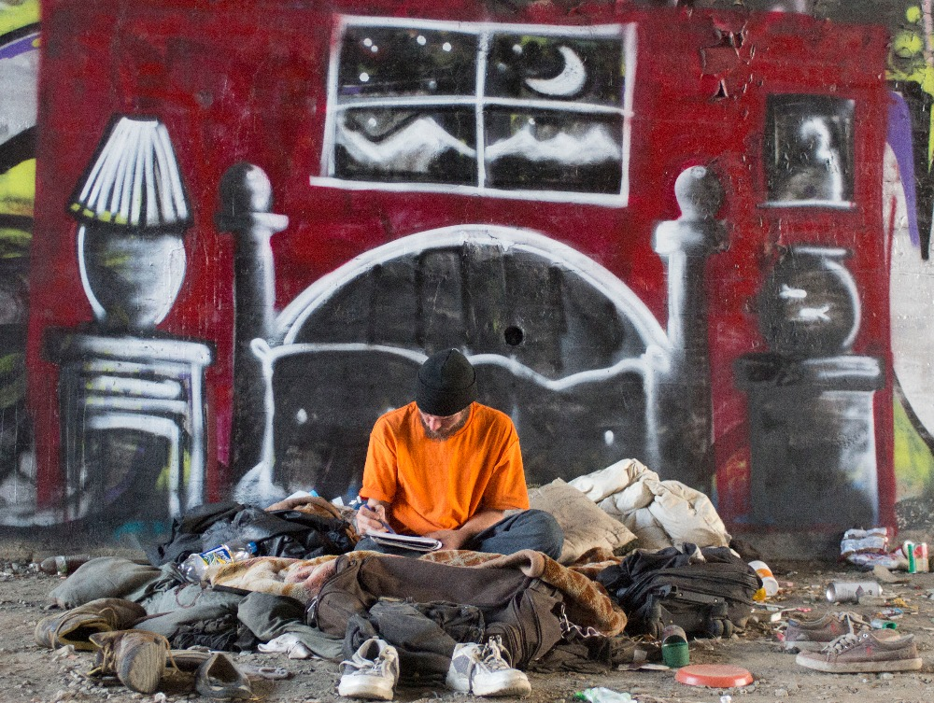

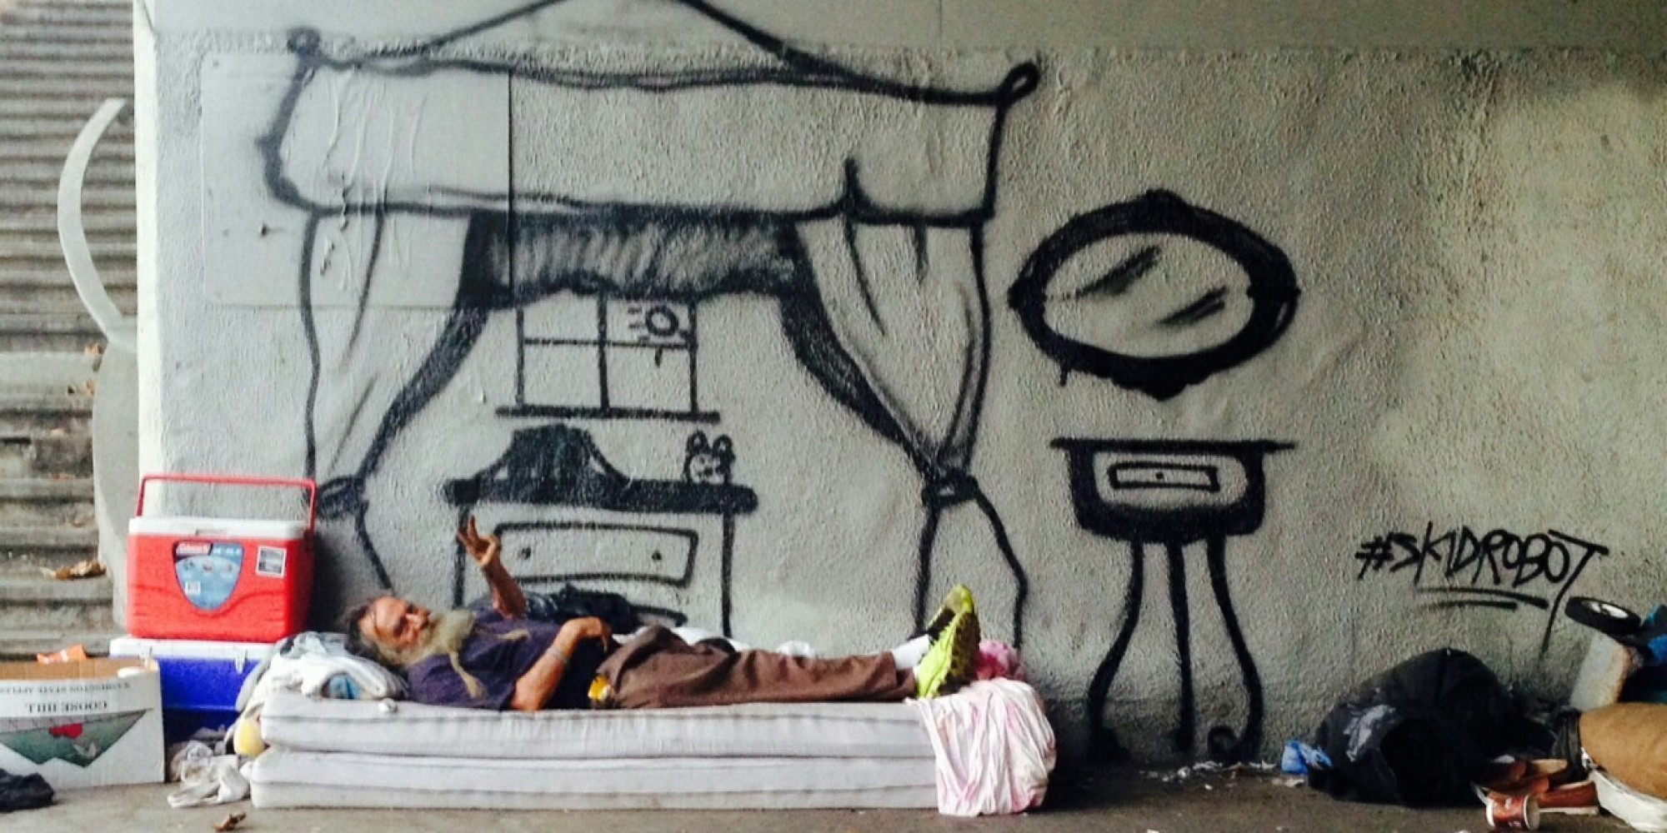
Untitled works of Skid Robot instagram user and street artist

“in the full range and feeling of [Modern English] ‘home’ is a conception that belongs distinctively to the word home…and is not covered by any single word in most of the [Indo-European] languages.” Buck, Carl Darling, A Dictionary of Selected Synonyms in the Principal Indo-European Languages, University of Chicago, (1949, reprinted 1988)
A collocation for English landscape coming from an industrial revolution poem Jerusalem, by William Blake (1808)
Gibran, Khalil:The Prophet (1923) p.19-20
Gibran, Khalil:The Prophet (1923) p.19
Catullus 63, Wigham, peter trans.The Poems of Catullus (1980)
Gibran, Khalil:The Prophet (1923) p.19-20
Morgan, Dian; The Best Guide to Eastern Philosophy (2001) p 34

